9 Moving the Cursor
10/19/2026
If you do not see the cursor, you will need to turn it on
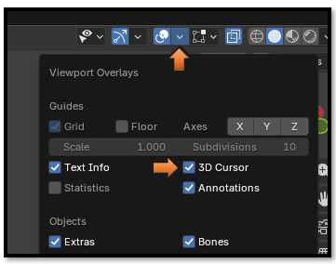

You can either use the cursor tool, or the hot key to locate the cursor. But if you use the cursor tool, it is easy to find that your move left the cursor in outer space, and not where you intended. So, it is best, if you have a vertex, to use the hot key and attach it precisely to the vertex location.

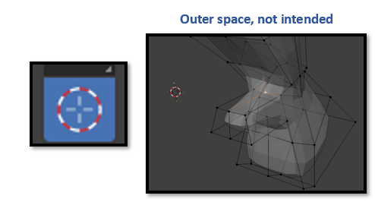

Hot Key
Shift -S, Cursor to Selected
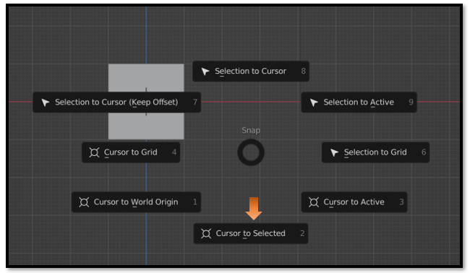
And it should jump to the selected vertex. And it is no longer in outer space.
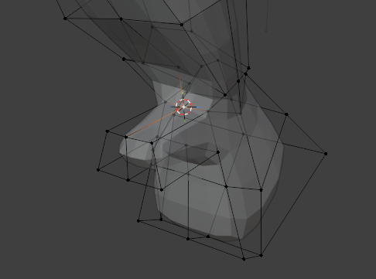
Just Remember to reset your cursor back to the World Origin, when you are done.
